

**UHC Doctor Chat & CPESN Partnership Job Aid**

*\*Updated February 2024 to reflect new member sign in/registration flow, including screenshots of the experience\**

**Purpose of this document:**

To provide guidance to CPESN pharmacies and alignment with Doctor Chat providers on the following:

1. CPESN Pharmacy phone outreach guidance and UHC Doctor Chat FAQ
2. CPESN pharmacy tech workflow when patients arrive at pharmacy
3. Expectations of the UHC Doctor Chat virtual visit
4. Demo screenshot of UHC Member Portal: New Member Registration and a Doctor Chat encounter

**1. Pharmacy Phone Outreach Guidance:**Notifying UHC members of new services available at pharmacy, including Doctor Chat

**Recommended verbiage to engage members:**

* “Hi, this is <insert your name> and I’m calling from <insert pharmacy name>. Our records show that <insert eligible UHC member name(s), i.e. parent and/or children’s names> is/are enrolled with UnitedHealthcare and because of that is/are eligible for additional services at our pharmacy. Do you have a few minutes to talk, so I can tell you about these services?”

**If patient responds ‘Yes’, feel free to continue by mentioning any and all of the below based on your understanding of the patient and your experience with them from your pharmacy:**

* “We offer on-site testing and some labs can be performed at our pharmacy (feel free to give examples of tests that could be relevant and are currently available at your store). Would you like to schedule a time to come in for <insert testing>.”
* **If patient responds ‘Yes’ and you’ve booked them for a time to come in, confirm date and close out call ensuring you have answered all of their questions:**
  + “I have you on the calendar for testing/labs on <insert date and time>. Do you have any other questions that I can assist with?”
* “You can connect with a doctor for a telehealth visit on UHC Doctor Chat from our pharmacy free of charge. We are happy to schedule your appointment if you need to connect with a doctor. Would you like to schedule a time to come in for a virtual visit?”
* **If patient responds ‘Yes’ and you’ve booked a time for them to come in, feel free to advise registering in advance and close out call confirming you have answered all of their questions:**
  + “I have you on the calendar for a visit on <insert date and time>. Do you own a computer or smartphone? If yes, you can register your myUHC member portal account at home before your visit which will give you access to UHC Doctor Chat - please go to www.myuhc.com and click on the Sign In or Register button to complete the few short steps. If no, we can help you register at our pharmacy before you start your virtual visit. Do you have any other questions that I can assist with?”

**UHC Doctor Chat FAQs:**

Additional info about the Doctor Chat program that may be useful to have on hand for patient questions

**Do I need to make an appointment to use Doctor Chat?**

No, once you have registered for the myUHC.com member portal, you can log in and access UHC Doctor Chat from the portal 24/7/365 to get access.

**Will my visit be secure?**

Yes. UHC Doctor Chat is compliant with the Health Insurance Portability and Accountability Act (HIPAA) and has been certified for security by the Health Information Trust Alliance (HITRUST).

### **Are there any copays or other charges I have to pay to use UHC Doctor Chat?**

No. As a UnitedHealthcare Community Plan member, you can use UHC Doctor Chat at no charge.

**How do I get started with UHC Doctor Chat?**

1. ​​Direct the member to www.myuhc.com
2. If not yet registered for the member portal, have them click Register and walk them through the UHC registration steps (screenshots of steps later in document)
3. If the member is already registered, have them click Sign In. They will enter their username and password, follow the prompts to confirm their identity.
4. Once signed into the member portal, click ‘Get Started’ on the ‘UHC Doctor Chat’ tile that appears on the home page *\*If member belongs to a plan that does not have UHC Doctor Chat enabled as a member benefit, a Doctor Chat tile will NOT be displayed in their portal view.*
5. Clicking the Doctor Chat tile will bring the member right into the UHC Doctor Chat web experience. To start a visit, the member will select their name on the profile page, click ‘Get Started’, and then confirm the state they are currently located in. They will have an option to add their health information (Medical Conditions/History, Prescriptions & Medications, and Allergies/Drug Sensitives), then the pharmacy tech will enter the agreed upon verbiage in the text box that appears (see blue text on next page) and click ‘Enter Chat’ to connect the patient to a provider in under 60 seconds for their virtual visits. All visits begin via chat and are multi-modal. Patients can upload photos and the doctor will seamlessly transition to video after the visit begins.
6. If a member does download the UHC Doctor Chat mobile app from the App or Play store, a single page of text will be displayed with instructions to sign into their UHC member portal account by clicking the button on the page. If the patient’s journey began with the mobile app, upon successfully signing into the member portal, the member will be dropped directly until the UHC Doctor Chat mobile web experience. All steps to start a visit on a mobile device are identical to those described for desktop web in the above bullet.   
   **\*If multiple family members are UHC Community Plan Members and want to have Doctor Chat visits at your pharmacy, please register/sign in as the first member who will be receiving medical care at myuh.com. After their visit, sign that member out of the portal and repeat the registration/sign in process for other family members before initiating their virtual visits.** Once assigned to an on duty provider, you are welcome to request a transfer to the same provider that you engaged with for the first family member to streamline the process and that will be accommodated, pending provider availability.

**Are these doctors from my clinic?**

No, UHC Doctor Chat doctors are board-certified and credentialed physicians who are licensed to practice across the U.S. These doctors are part of the CirrusMD Provider Network.

**Where can I learn more about this program?**

Visit [www.uhcdoctorchat.com](http://www.uhcdoctorchat.com). If a member needs help verifying eligibility or accessing the UHC member portal, have them call the phone number on the back of their ID card or use the chat feature within the myUHC portal to speak with a member advocate.

### **Can I use the UHC Doctor Chat app for other family members?**

If family members are UnitedHealthcare Community Plan members in Virginia, they are eligible for UHC Doctor Chat. Everyone will need to register their own account at www.myUHC.com and complete their visits individually to document the notes in their own medical records. A parent or legal guardian can create an account for minor children under age 18.

**What can these doctors help with?**

* **General Health Questions:** Do you have questions about medication side effects, lab orders/results, recommended health screens, or follow up questions after recent in-person care?
* **Questions About Where to Receive Care:** Before you schedule an in-person appointment or go to the ER, chat with a doctor instantly on Doctor Chat.
* **Urgent Care:** feel sick, but it’s not an emergency*, minor injuries, coughs, fevers, sore throat, stomach pain, rashes, allergic reactions, animal/insect bites, and pediatric care such as common viral infections
* **Mental Health:** anxiety, depression, stress, insomnia (18+ only)
* **Chronic Care and Prevention:** Is your asthma under good control? Questions about weight loss, smoking cessation, managing diabetes, hypertension, or acne?
* **Women’s Health:** birth control, irregular bleeding, urinary tract infections, wellness
* **Prescriptions or refills, as clinically appropriate**: controlled substances, non-therapeutic and certain other drugs may not be available *\*Remember, if you’re having a life-threatening emergency, dial 911.*

**2. CPESN pharmacy tech workflow when patients arrive at pharmacy (prep for Doctor Chat visit)**

* Greet patient/help them register for Doctor Chat if they haven’t done so in advance (steps on previous page). Note: if multiple family members are eligible, each family member will need to be registered at www.myUHC.com individually.
* Set up patient in secure area with tablet for their virtual visit
* **Help initiate the visit for the patient with the patient in the room using agreed upon verbiage to include your name, pharmacy name and location, patient’s name and reason for virtual visit. This is essential to alert the doctor that this visit is happening from a pharmacy where additional resources are available vs. from the patient’s home. Please feel free to work from this script and save the below somewhere near the iPad so it is used consistently for all member visits:**
  + **This is the Pharmacy Technician, <insert your name>, at <insert pharmacy name + address, i.e. Peoples Pharmacy,1446 Church Street, Suite C, Norfolk, VA 23504; phone:757-227-4677> connecting member <insert member name> who has concerns regarding <insert concern: i.e. a rash that she is having, chronic condition medication refill questions, recent lab/test results and wants to discuss next steps, general medical questions, mental health, looking to ask medical questions for themself and then will also be looking to have a visit afterward for additional family members, etc.>.**
* Pharmacy tech to upload any photos that would be relevant (i.e. test results from tests just completed) or note any specific things that the patient is coming on to discuss
* Pharmacy tech can leave patients to have privacy for virtual visits and let patients know how to reach them if assistance is needed, on site testing is needed, etc.
* If multiple family members are eligible, please note that each visit is only for one individual to ensure the doctor can document results in the appropriate medical record. Encounter experience process needs to be completed for the first family member before additional family member visits can take place. Please schedule additional time if virtual visits are needed for multiple family members.
* Screenshots of example encounter included later in document

**3. Expectations of the Doctor Chat virtual visit**

* All visits begin with text messaging. Patients have the ability to upload photos to the chat (i.e. photo of rash or of test results).
* The provider will initiate the video component of the visit. This may not be right at the beginning as we always gather some screening question information with texting first, but Doctor Chat providers will make every effort to initiate this process more quickly to aid the member.
* Doctors practice evidence based medicine and can write prescriptions to be filled at the pharmacy, as clinically appropriate. Doctor Chat does not write prescriptions for controlled substances.
* **The pharmacy tech needs to identify that the visit is taking place at the pharmacy using verbiage so doctors know other resources available to the member during the visit.**
* Visits can stay open as long as needed (no time limits). If a patient is advised by the attending physician to get on-site testing and needs to step away from virtual visit to get that completed, and then comes back into chat with the results 15 minutes later, Doctor Chat will keep the encounter open so they can continue the visit with that additional information once the patient returns.
* Pharmacy tech will clear PHI from the tablet after the visit before allowing another patient to use the shared device:
  + 1. Sign member out of Doctor Chat
  + 2. Sign out of email (if used for registration on iPad)  
    3. Delete any photos taken

**UHC Doctor Chat C&S Clinical Playbook (CPESN section) – for CirrusMD Doctor Usage**When you initiate the virtual visit using the agreed upon format noted above, this will alert the attending doctor that you are joining from a pharmacy. They will then view our clinical playbook which includes the below section with an overview on the partnership for participating markets (VA, NC, FL).

**Community Pharmacy Enhanced Services Network (CPESN Partnership)**

VA rural members face problems such as: Limited access to Broadband, Limited option for care & in-person appointment time availability, Lack of transportation, long travel time, increased travel costs, and Lack of Privacy. Many individuals travel more than 45 minutes to access primary care services. Effective 7.1.23, 10+ CPESN facilities across VA will offer a communal tablet in a private location that members can use for a telehealth visit on Doctor Chat while on-site at the pharmacy (location’s pharmacy tech will assist with setup). Effective 2.16.24, this program has expanded to ~25 additional pharmacies in FL + NC.

**Pharmacy Identification**

Pharmacy Technician/Community Health Worker will provide a tag line during the initiation of visit stating that visit is occurring in pharmacy with the name and address of the pharmacy. Example: This is the Pharmacy Technician, Sally, at Peoples Pharmacy,1446 Church Street, Suite C, Norfolk, VA 23504; phone:757-227-4677 connecting member Teresa Bradley who has concerns regarding a rash that she is having.

**If a member identifies as chatting from a CPESN facility, CirrusMD providers should know:**

* Pending availability, **the following tests can be performed in the moment by an on-site Pharmacist:** Blood Pressure, COVID-19, Influenza, Strep A, RSV, Urinary Tract Infection, Blood Glucose, Hemoglobin A1c, HIV, Hepatitis C, Lipid Panel, GFR
* Pending availability, **the following vaccinations can be performed in the moment by an on-site Pharmacist:** Flu, TDaP, Hepatitis A, Hepatitis B, Pneumonia, Shingles, RSV, GARDASIL, COVID booster (availability may vary on this if stores aren’t able to access single dose syringes) or others upon request that may require special order.
* Pending availability, **the following therapeutic injections (IM or SubQ) can be performed at the moment by an on-site Pharmacist:** GLP-1 agonist, LAIs, B12, insulin, depot birth control, testosterone, Prolia, etc.

If a prescription is written during the encounter, the members can have it immediately filled on-site at the CPESN pharmacy before heading home. However, the member has freedom of choice to have a prescription sent to a pharmacy of their choice.

Participating pharmacies information for ease of locating in ePrescribing system or referrals to local pharmacy for testing services:

**VIRGINIA**

1. Peoples Pharmacy: 1446 Church Street, Suite C Norfolk, VA 23504 757-227-4677
2. Bremo Pharmacy: 2024 Staples Mill RD Richmond, VA 23230 804-288-8361
3. Walnut Hill Pharmacy: 1950 South Sycamore Street Petersburg, VA 23805 804-733-7711
4. Top Notch Family Pharmacy: 943 Preston Ave Charlottesville, VA 22903 434-995-5595
5. Martin's Pharmacy, Inc.: 400 N. Washington Ave Pulaski, VA 24301 540-980-4060
6. Halifax Pharmacy: 4121 Halifax Road South Boston, VA 24592 434-575-0511
7. Glade Pharmacy: 33472 Lee Hwy Glade Spring, VA 24340 276-429-2004
8. Clark's Pharmacy: 402 Palmer Avenue Saltville, VA 24370 276-496-7211
9. Martin's Pharmacy of Rural Retreat: 100 W Buck Ave Rural Retreat, VA 24368 276-250-2160
10. Cumberland Pharmacy: 1756 Anderson Hwy Cumberland, VA 23139 804-492-4325
11. Amelia Pharmacy: 15412 Patrick Henry Hwy Amelia, VA 23002 804-561-6885
12. VanDorn Pharmacy: 5724 Edsall Road, Alexandria VA 22304 703-348-7186

**NORTH CAROLINA**

1. ASKK LLC dba Southside Discount Pharmacy, 3085 Waughtown St, Winston-Salem, NC 27107, 336-830-8774

2. Broad Street Pharmacy, 8055 Broad St, Rural Hall, NC 27045, 336-696-0444

3. Carolina Pharmacy-Arboretum, 8035 Providence Rd #300, Charlotte, NC 28277, 704-909-4700

4. Josefs Pharmacy, 2100 New Bern Ave, Raleigh, NC 27610, 919-212-2555

5. Moose Pharmacy of Concord, 270 Copperfield Blvd NE, Concord, NC 28025, 704-784-9613

6. Moose Pharmacy of Locust, 1750 W Main St, Locust, NC 28097, 704-888-2114

7. Moose Pharmacy of Mt. Pleasant, 8374 W Franklin St, Mt Pleasant, NC 28124, 704-436-9613

8. Moose Pharmacy of Salisbury, 1408 W Innes St, Salisbury, NC 28144, 704-636-6340

9. Village Pharmacy of Wake Forest, 900 S Franklin St, Wake Forest, NC 27587, 919-556-2757

10. Wilson Value Drug, 404 Nash St, Wilson, NC 27893, 252-293-4177

11. You 1st Pharmacy, 240 E Garrison Blvd, Gastonia, NC 28054, 980-320-0160

**FLORIDA**

1. Burry's Pharmacy, 500 Webster St, Leesburg, FL 34748, 352-787-3787

2. Cheek & Scott Pharmacy - Jasper, 1150 N W U.S. Hwy 41 #13, Jasper, FL 32052, 386-638-0101

3. Cheek & Scott Pharmacy - Lake City, 4785 W US Hwy 90, Lake City, FL 32055, 386-754-5377

4. Cheek & Scott Pharmacy - Live Oak, 1520 Ohio Ave S, Live Oak, FL 32064, 386-362-2591

5. Community Pharmacy of Deltona, 1240 Providence Blvd Unit 1&2, Deltona, FL 32725, 386-259-5435

6. Community Pharmacy of Port Orange, 3755 S Nova Rd unit a, Port Orange, FL 32129, 386-256-3177

7. Epic Care Pharmacy, 3948 Pembroke Rd, Pembroke Park, FL 33021, 954-963-2113

8. G & R Healthmart Pharmacy - Beverly Hills, 3791 N Lecanto Hwy, Beverly Hills, FL 34465, 352-527-3111

9. G & R Healthmart Pharmacy - Homasassa, 5691 S Suncoast Blvd, Homosassa, FL 34446, 352-628-0096

10. Homestead Community Pharmacy, 925 NE 30th Terrace STE 200, Homestead, FL 33033, 305-245-1800

11. Palms Pharmacy, 17008 Palm Pointe Dr, Tampa, FL 33647, 813-252-9063

12. Panama Pharmacy at eMed, 6022 Atlantic Blvd, Jacksonville, FL 32207, 904-990-1054

13. Super Discount Pharmacy, 1423 South Collins Street Plant City, Florida 33563, 813-752-1133

14. The Medicine Shoppe Pharmacy #1731, 216 Oakfield Dr, Brandon, FL 33511, 813-662-9926

**4. UHC Member Portal: New Member Registration**

Clickable Demo: <https://welcometomyuhc.com/community-state/medicaid/registration/register.html> (screenshots below) *\*Note: You don’t need to enter anything, just click through on the action buttons*

1. Direct member to [www.myuhc.com](http://www.myuhc.com/) where they can sign into the member portal. If they haven’t created an account previously, they will need to set up their account in order to access UHC Doctor Chat. Click ‘Register’.

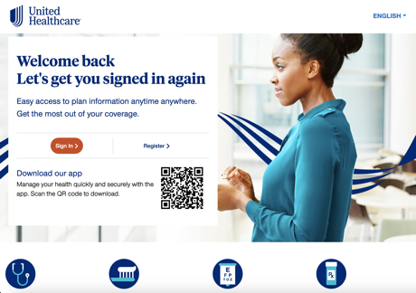

1. Enter first name, last name, date of birth, and member ID as it appears on their UHC member ID card. Hit ‘Continue’ button.  
   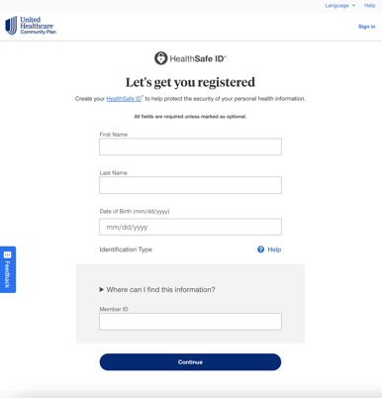
2. Enter username, password, and email address. Uncheck box for ‘Remember me on this device’, as you are using a shared device. Check the ‘I agree to terms’ box, then hit ‘Continue’.  
   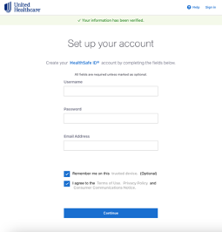
3. Account confirmation – select preference for a text message or a phone call, and enter the member’s mobile phone number. Hit ‘Text me’ button to prompt sending of confirmation code.  
   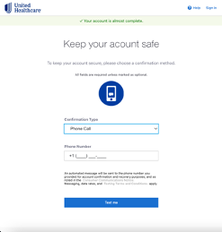
4. Enter confirmation code received via text or call to patient’s mobile device. Click ‘Create Account’.  
   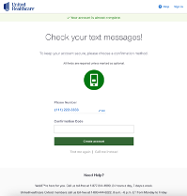
5. Account has been created. Email, username, and phone number now linked to account are displayed for reference. It might be a good idea to have the member write their information down on a piece of paper to take home with them after the visit. Click ‘Continue to Account’.  
   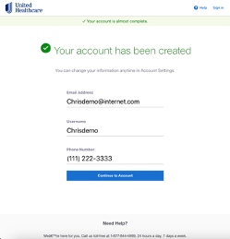
6. You will land on the member portal dashboard home page. Click ‘Get Started’ on the UHC Doctor Chat tile to initiate a visit.  
   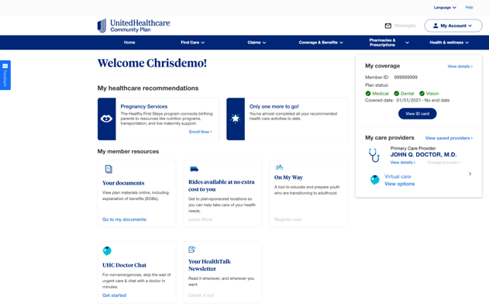

*\*\*Registration support: If a member needs help verifying eligibility or accessing the UHC member portal, have them call the member services phone number on the back of their UHC Member ID card.*

**Starting a Doctor Chat visit from the Member Portal**Clickable Demo of Medicaid experience: <https://welcometomyuhc.com/community-state/> (screenshots below)

1. Click ‘Get Started’ on the UHC Doctor Chat tile of the dashboard homepage to initiate a visit.  
   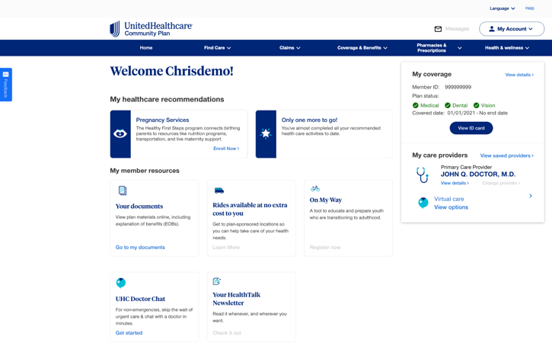
2. Welcome page - click ‘Continue’  
   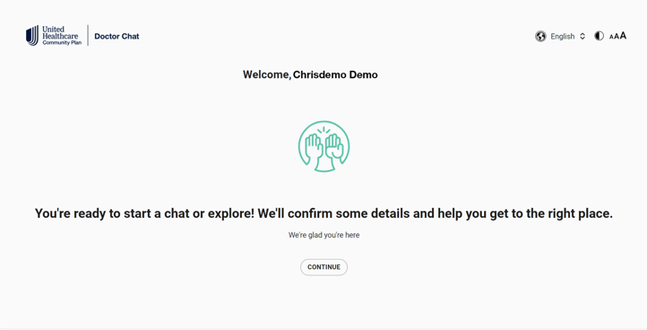
3. Select profile - click ‘Primary’ tile with patient’s name.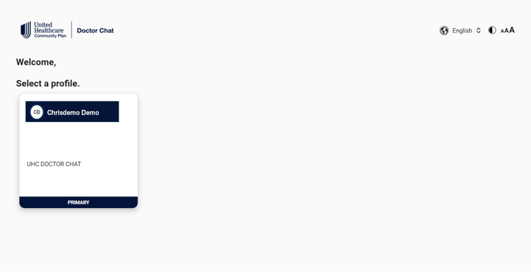
4. Click ‘Get Started’.  
   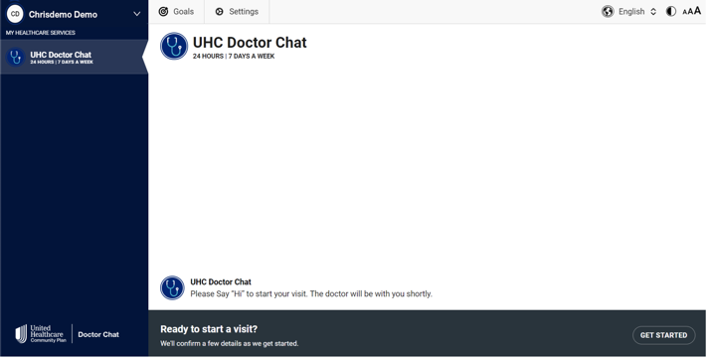
5. Select the state the patient is currently located in from the drop down box, the hit ‘Continue’.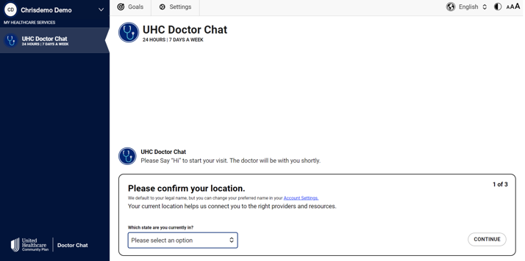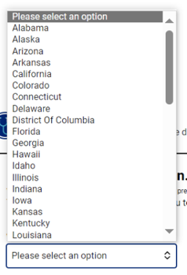
6. Add known health information (Medical Conditions/History, Prescriptions & Medications, and Allergies/Drug Sensitives), the hit ‘Continue’.

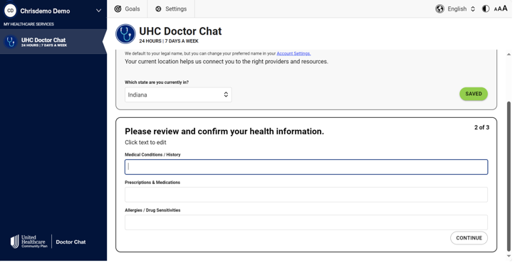

1. In the “Let our providers know how they may help’ box, enter agreed upon verbiage template for workflow: i.e. This is the Pharmacy Technician, <insert your name>, at <insert pharmacy name + address, i.e. Peoples Pharmacy,1446 Church Street, Suite C, Norfolk, VA 23504; phone:757-227-4677> connecting member <insert member name> who has concerns regarding <insert concern: i.e. a rash that she is having, chronic condition medication refill questions, recent lab/test results and wants to discuss next steps, general medical questions, mental health, looking to ask medical questions for themself and then will also be looking to have a visit afterward for additional family members, etc.>. Then hit ‘Enter Chat’ to connect to an on-duty provider.  
     
   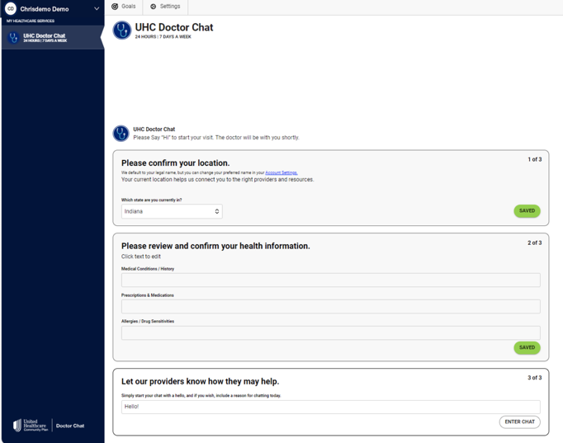
2. An on-duty provider is assigned in under 60 seconds. You will be notified when they join the chat.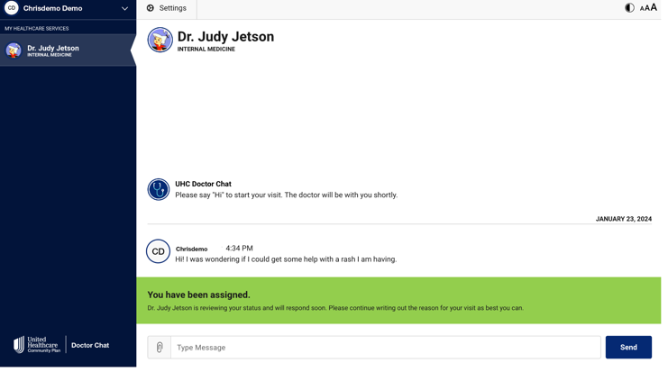
3. All visits begin with text messaging.  
   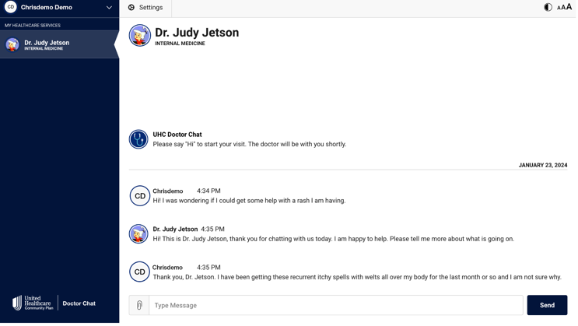
4. Patients can upload a photo (i.e. image of test results from a test performed before the visit at your pharmacy) by clicking on the paperclip icon to the left of the type message box. **If this is the first time you are sharing images in the Doctor Chat app from your store’s iPad, you will need to allow access to your device’s camera/photo library.** Patient sees a preview of the image they selected, has an option to add an image description, then hits upload to share the photo in the chat. Once received, the provider can enlarge the image on their end for review.  
   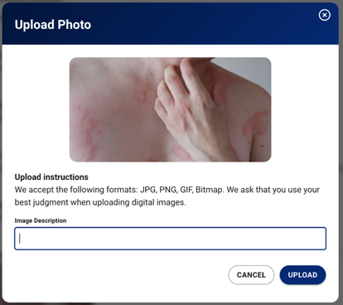
5. As clinically necessary, providers can administer standardized assessments during the virtual visit. Anxiety (GAD7), depression (PHQ9), and asthma (ACT) are all built into the platform.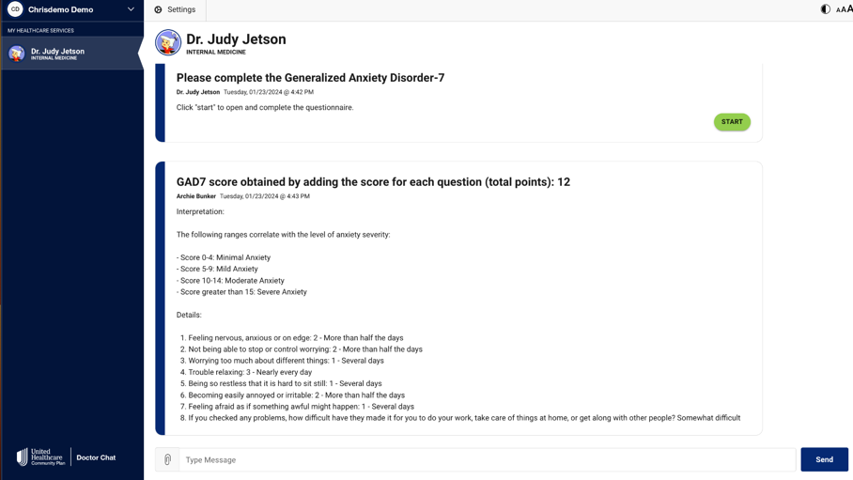
6. The provider can also seamlessly initiate a video connection in the visit. This will drop a tile within the chat thread for the patient. The member clicks on the 'Join Call' button. **If this is the first time you are conducting a video connection in the Doctor Chat app from your store’s iPad, you will be prompted to allow access to their device's microphone and camera.** After clicking on 'Join Call' and establishing the video connection, the provider will appear in the bottom left hand corner of the page (from the patient's view), with the patient's own video stream embedded as a small box within the provider imagery. You'll see the chat thread is still visible once a video connection is established. This allows the provider to add resources and recommendations into the stream as needed while on video with the patient so the member can revisit those recommendations after the virtual visit concludes.  
    To make the picture larger during a video session, the patient can click on the **X** icon to expand the video to full screen (this will cover up the chat thread temporarily). Clicking this icon again will minimize the video back into the bottom left hand corner. For those who are deaf or hard of hearing, clicking on **CC** displays closed captioning for audio (of both patient and provider text) above the video image. The gear icon displays options the patient has for audio/video . If you run into technical difficulties (maybe their device is hooked up to multiple speakers/cameras), settings will allow you to choose a different audio/video input.  
   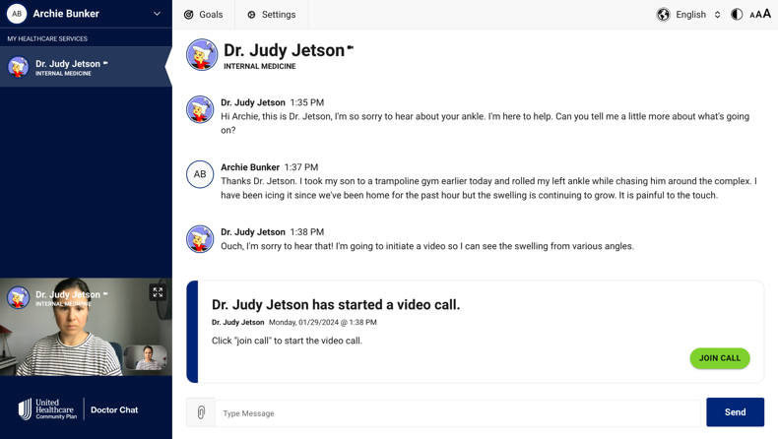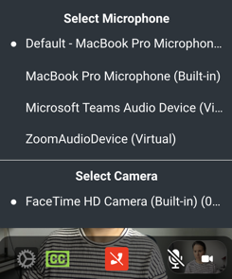Once the video portion of the visit concludes, the patient and provider can communicate additional details in the chat thread.  
   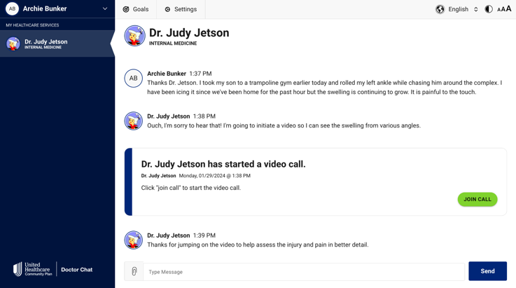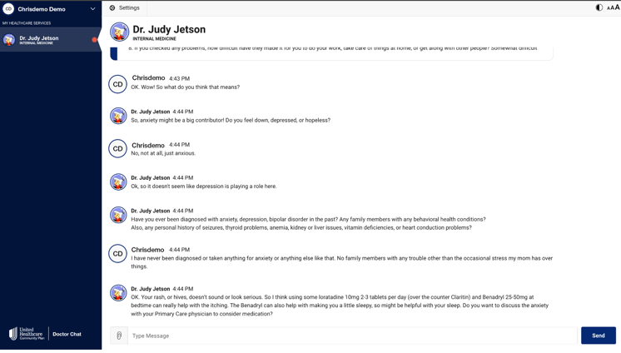  
   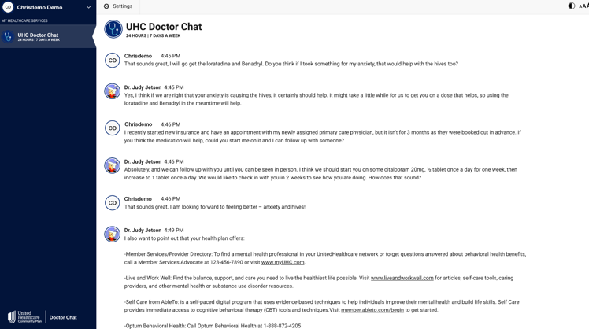
7. Once all medical advice has concluded, the doctor will end the virtual visit with a Progress Note, which is meant to serve as a standalone summary of the virtual visit. If you have connected your store’s device to a printer, you can click the ‘print for PCP’ button to print the summary for the patient to take home. They can log back into the member portal from home and access their chat history at any time.  
   